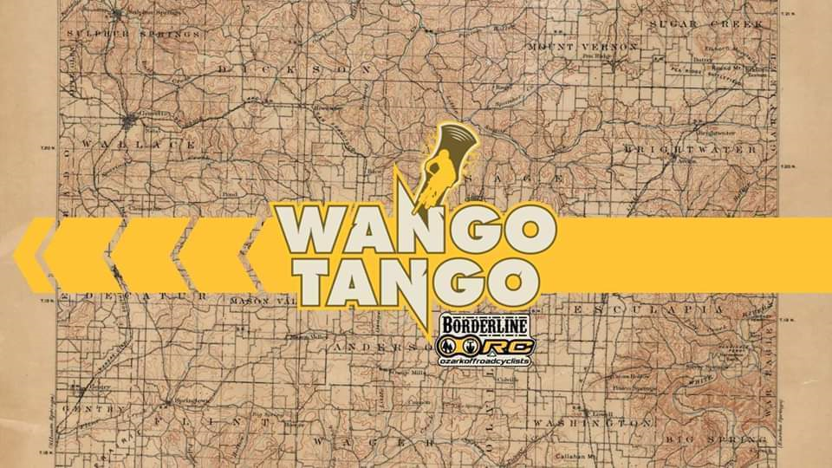

4-PERSON RELAY FEMALE
Quad Squad 12 Laps First Place
Ride For Rex 8 Laps Second Place
4-PERSON RELAY MALE
The Cute Boys 13 Laps First Place
The Cool Cats 12 Laps Second Place
French Hillbillies 12 Laps Third Place
Ride For Rex 11 Laps
Josh Hunts Team 10 Laps
4-PERSON RELAY JUNIOR CO-ED
Fortnite 12 Laps First Place
Eureka Springs MTB 11 Laps Second Place
4 & There Ain’t No More 10 Laps Third Place
2-PERSON MALE
Labes 16 Laps First Place
O-Sage Express 15 Laps Second Place
BMX 13 Laps Third Place
Go Fast Eat Dirt 11 Laps
2-PERSON CO-ED
Blair Squared 12 Laps First Place
Cox in Socks 11 Laps Second Place
The Olou Two 11 Laps Third Place
Alternate Wave 10 Laps
Blah 10 Laps

SOLO FEMALE
Natalie Peet 9 Laps First Place
Note Louis 6 Laps Second Place

SOLO MALE
Ben Glenn 11 Laps First Place
James Blalack 8 Laps Second Place
BJ Latta 6 Laps Third Place

JUNIOR SOLO MALE
Edmond Niederman 12 Laps First Place
Leo Rodriguez 7 Laps Second Place
Jackson McQuiston 6 Laps Third Place

SOLO E-BIKE MALE
Robert Whitby 9 Laps First Place
Matt Timboe 8 Laps Second Place

